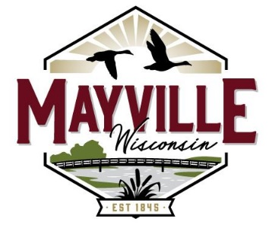

WATER & WASTEWATER COMMISSION
REGULAR MEETING AGENDA
Tuesday, September 12th, 2023- 4:00 PM
City Hall

(rescheduled from 9/5/23 meeting)

AGENDA
(A Quorum of Council Members May be Present)

- Call to Order and Roll Call
- Citizens Comments
Citizen Comments are to be kept to a maximum of five minutes per speaker unless the chairperson allows an extension of time. Each citizen is to make comments at the podium after stating name and address. Each citizen may comment only one time per public hearing / meeting.
- Approve Consent Agenda.
  - Minutes of August 1st, 2023 Commission Meeting
  - Minutes of July 25th, 2023 Special Meeting
  - Water Utility Bills
  - Wastewater Utility Bills
- Discussion and possible action regarding future well and well house projects at wells 2, 3, and/or 5.
- Discussion and possible action regarding design, bidding, & funding services contract with MSA Professional Services for wastewater facilities upgrade project.
- Water Report.
  - Well & Distribution System Report/Discussion
- Wastewater Report.
  - Sewer System Report/Discussion
- Discussion and possible action regarding time of regular water & wastewater commission meeting.
- Convene into Closed Session Pursuant to Section 19.85 (1) (c) considering employment, promotion, compensation, or performance evaluation data of any public employee over which the governmental body has jurisdiction or exercises responsibility.
  - Discussion and possible action regarding budgetary employee compensation amounts.

- Adjournment.

Next scheduled meeting is October 3, 2023; 4:00 PM at Mayville City Hall.

Burt Bushke
Commission President

